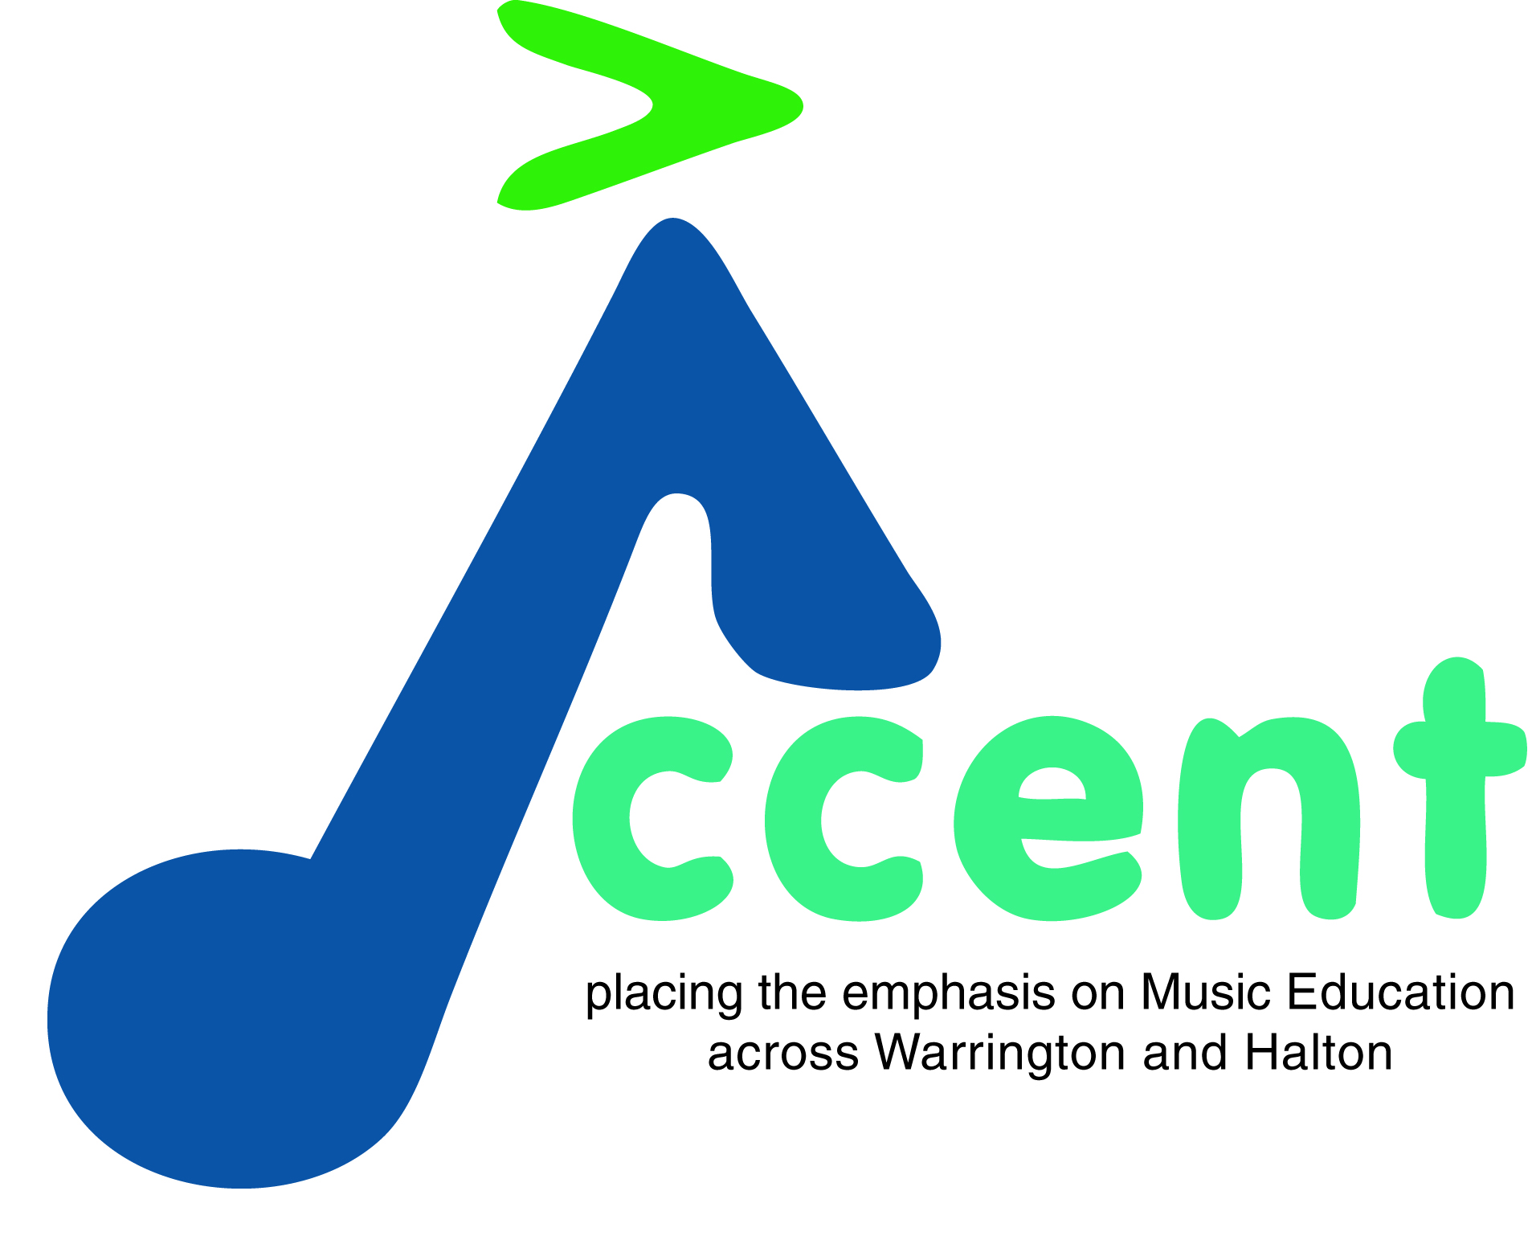
ACCENT SAXOPHONE PLAY DAY REGISTRATION

Please note that the information given on this form will be treated in strict confidence.
This form should be completed and signed by the participant OR their parent / guardian for minors. Please write clearly in capital letters.

Participant’s Personal Details
First name: | Surname:
Name of parent/guardian (if applicable):
Emergency phone number:
Approximate Grade:
Years Playing Instrument:

Participant’s Medical Information
Does the participant have any medical history that we should be aware of?

Has the participant ever had an allergic reaction to any of the following:

Antibiotics Yes No Bee/wasp sting Yes No
Medications Yes No Plasters Yes No
Does he/she carry an Epipen? Yes No
If yes please provide an extra epipen.
Are there any other medical, social or emotional considerations that we should know about?
Yes No
If yes, please give details:

Does he/she currently have a bone, joint or muscular problem which may be aggravated by exercise or playing their instrument?

Does the participant have any dietary requirements?
Parent/Guardian declaration and permission
- I certify that I have given a full and complete account of all medical information and that the above-named is, to the best of my knowledge, in good health, free from infection and has not been in recent contact with any contagious diseases (eg meningitis). I hereby give permission to the Nurse selected by Accent to give treatment and for Accent staff to request treatment by a doctor for the individual named above.
Signature of parent/guardian: | Date:

Consent form for Accent staff commissioning photography

Saxophone Play Day 28 April 2018

Participant Full Name: ________________________________________________

D.O.B: ________________________________________________

Name of Parent/Guardian (if under 18): ________________________________________________

Contact Tel No: ________________________________________________
To comply with the Data Protection Act 1998, we need your permission before we take any images. Please answer questions 1 to 4 below, then sign and date the form where shown. Please return the completed form to Accent Music Education Hub
To the Parent/Carer |  |  |  |  | Please circle your answer
- May we use the participant’s image in our printed promotional publications? |  |  |  |  | Yes / No
- May we send out the participant’s image with our press releases? Please note that in this circumstance we would wish to use first name only in the accompanying text.  - May we use the participant’s image on our website/ social media ? |  |  |  |  | Yes / No  Yes / No
- May we record the participant’s image on our promotional videos? |  |  |  |  | Yes / No
Please note that websites can be viewed throughout the world, not just in the United Kingdom where UK law applies. Please also note the conditions for using these images on the back of this form.
I have read and understood the conditions of use on the back of this form.
Signature: |  |  | Date:
Your name (in block capitals):
Conditions of use
- This form is valid for projects within Accent Music Education Hub only.
- We will not include details or full names (which means first name and surname) of any child in an image on video, on our website, or in printed publications, without good reason. We may include the full name of a competition prize winner if we have their consent. However, we will not include the full name of a child used in promotional literature.
- We will not include personal e-mail or postal addresses, or telephone or fax numbers on video or on our website or in printed publications.
- If we use images of individuals, we will not use their name in the accompanying text or photo caption without good reason. And if a pupil is named in the text, we will not use a photograph of that pupil to accompany the article without good reason. For example, we may include a picture and full name in a press release or of a competition prize winner in another publication if we have their consent. However, we will not include a picture and full name of a pupil in any promotional literature.
- We may use group or class images with very general labels, such as “a keyboard lesson” or “a whole school performance”.
- We will only use images of pupils who are suitably dressed, to reduce the risk of such images being used inappropriately.

