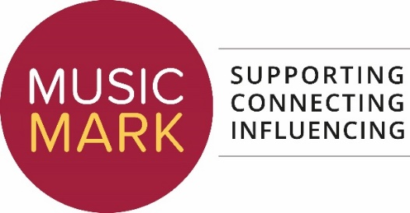
PROXY NOTICE
Nomination Form to appoint a Proxy for the Music Mark AGM 4th November 2021
This form is to be completed by any individual member or nominated representative of an organisation member of The UK Association for Music Education – Music Mark who will not be able to attend the charity’s AGM on Thursday 4th November 2021 at 2pm but would like to nominate someone to act as their proxy.
Full details of the process of appointing and using a proxy are detailed in the charity’s current byelaws (section 10). These can be found here or can be sent to a member on request.

Nominee (the Member appointing the proxy):
Please provide your full name, organisation (if relevant) and address

Nominee's Proxy: (the Member you wish to act on your behalf)
Please provide your full name, organisation (if relevant) and address

I will not be attending the Music Mark AGM on Thursday 4th November 2021, and therefore have asked the above individual to act as my proxy.
Signed (by the Nominee):

Please send the completed document by 5pm on Wednesday 3rd November 2021 to bridget.whyte@musicmark.org.uk as an attachment.
To revoke a proxy appointment, please send a request in writing no later than the start of the meeting (2pm, Thursday 4th November, 2021).

