

Applicant Pack: Head of Department - Music

Salary: Points 1 to 9 of the sixth form colleges teacher pay scale, currently £33,465.00 to £51,714.00 per annum

A full-time Head of Department is responsible for teaching four groups. In addition to the basic salary outlined above, the postholder will receive a base allowance of £3,797.68, plus a supplementary payment of £14.60 per enrolled student. The Head of Department allowance is capped at £13,438.00 per annum.

The Head of Department allowance is reviewed every two years and calculated using the average enrolment data from the preceding three years (Day 42 data). The postholder will be notified in January of the review year of any recalculated allowance, which will take effect from 1 September of that year.

The Head of Department allowance for Music for the period 24 August 2026 to 31 August 2028 will be £5,325.82 per annum.

A Head of Department generally manages one specification. As the role will involve responsibility for two specifications (A-Level Music and BTEC Music Performance), the postholder will be paid an additional Head of Subject allowance of £2,604.79 per annum.

The total salary for this role is therefore £41,395.61 to £59,644.61 per annum.

Additionally, the College are offering a £3,000.00 Golden Hello payment, payable on commencement of employment.

FTE: Full-time

Pension: Teachers’ Pension Fund, plus Death in Service Grant of 3 x your annual salary

Contract type: Permanent

Other benefits:
- Access to the Schools Advisory Service EAP, offering counselling, physiotherapy and other support services
- Free use of onsite gym facilities (6.45 am to 8.15 am and 4.00 pm to 7.00 pm)
- Eye test vouchers
- Flu vaccination vouchers
- Cycle to work salary sacrifice scheme
- Health and wellbeing events throughout the year, including a dedicated staff wellbeing day
- Enhanced maternity and paternity pay
- Opportunities for personal and professional development

Reports to: Assistant Principal – Quality of Education

Closing date: Sunday 21 June 2026

Start date: The preferred start date for this role is 24 August 2026. However, we recognise that many candidates, particularly those currently working in education, may be subject to longer contractual notice periods. We are committed to appointing the right person and are therefore willing to be flexible on the start date where necessary. We would encourage interested candidates to apply regardless of their availability, as we will work with the successful application to agree a suitable commencement date.

Welcome Letter

On behalf of Greenhead College, thank you for your interest in the post Head of Department - Music. We are pleased that you are considering Greenhead College as the next stage in your career, and we hope, subject to matching our criteria, you will apply.

Greenhead College is situated on a welcoming and attractive campus close to Huddersfield town centre, adjacent to the picturesque Greenhead Park. We are just a short drive from the M62 and within walking distance of both the train and bus stations, making the College highly accessible for applicants from across the Northwest and Yorkshire.

Approximately 2900 students attend the College studying predominantly A Level courses across 35 subjects. The academic structure of the College is based on Heads of Curriculum who are subject specialists. The College also employs a team of Tutors, experienced in pastoral care, careers guidance and trained in Mental Health First Aid. Alongside their academic studies, students benefit from a rich extra-curricular enrichment offer and a wide range of project and work placement opportunities through our Step Into Your Future scheme.

Our commitment to student and staff well-being is reflected in our achievements. In July 2024, we received the Further Education Mental Health Gold Award in recognition of the comprehensive support we provide. In March 2025, OFSTED once again graded the College as ‘Outstanding’ in all six key areas, and as making a strong contribution to skills needs, identifying no areas for improvement. Most recently in April 2025, we were honoured to be named Further Education College of the Year at the Educate North Awards. These accolades highlight the dedication and high standards demonstrated by our students and staff across all roles.

The College is a great place to work, with a warm, inclusive atmosphere existing between students and staff. Our staff are recognised for their hard work and are encouraged to inspire each another, and to develop and grow. We are proud to have a strong and able College Leadership Team, and a highly experienced Board, who work collaboratively to deliver the College’s purpose and principles, and strategic priorities.

The Music Department at Greenhead consists of around 100 students studying A Levels in Music and Music Technology and a BTEC National Level 3 Extended Certificate in Music Performance. The role of Head of Department line manages the Head of Subject - Music Technology and a Music Technician. Despite modest accommodation, the department is well resourced with plans to further incrementally improve and update over the coming years. We follow the EDUQAS A Level Music Specification, and the Pearson A Level Music Technology and BTEC Music Performance specifications.

Music at Greenhead is not just about the curriculum; the Music Department makes a sizeable contribution to the College’s extensive enrichment programme. In the past few years, Music enrichment activities have included Brass Ensemble, Choir, Soul Band, Music Theory, Advanced Music Theory and Classic Album Club, alongside an Autumn / Spring Concert, ‘Live Lunch’ and ‘Big Gig’ lunchtime performances and our annual Festival of Carols at Holy Trinity Church. Visit the Music Department YouTube page to see our students in action.

There are two main teaching rooms with Mac M2 Pro computers running Logic Pro and Sibelius Ultimate, alongside a suite of breakout practice rooms and two larger rehearsal rooms. Our main studio was upgraded in Summer 2024 to include new furniture and studio equipment. We also have a selection of industry-standard microphones to support students’ high achievement in their Music Technology non-examined assessment work. There is also a smaller, post production studio.

This is an exciting time to be joining us. We were one of only 50 schools and colleges nationally to receive multi-million-pound funding for a new four-storey science building, which opened in November 2023, with the final building work and landscaping completed in August 2025. We continue to invest in our facilities and have an ambitious capital investment plan spanning the next five years.

If you have any queries about this role, please contact our Human Resources Team via email jobs@greenhead.ac.uk who will be happy to help.

We look forward to receiving your application.

Best wishes,


Mo Bunter
Principal


Job Description: Head of Department - Music

Duties & Responsibilities:

In the first instance, the roles duties and responsibilities are listed below. This list is an outline of the key tasks and responsibilities and is not intended as an exhaustive list. As the needs of the College change, post-holders may be expected to take on or relinquish responsibilities, as directed by the Assistant Principal or other members of the College Leadership Team.

Role-specific responsibilities:

- Teaching between 3 and 4 blocks towards examinations in A Level Music, BTEC Level 3 National Music Performance (Extended Certificate) and Music enrichment activities. The balance between teaching and enrichment will be agreed with the Assistant Principal (Quality of Education). In the past, enrichment activities have included student ensembles, music theory classes, music concerts and Festival of Carols, music for open events and similar, and attendance at external events such as Marsden Jazz Festival, Music For Youth and Mrs Sunderland.
- Weekly subject support sessions with students.
- To lead on the teaching, learning and assessment of the A Level Music and BTEC Music Performance specifications.
- Engage with external partners e.g. Musica Kirklees and the University of Huddersfield.
- Departmental duties of curriculum administration and leadership as required to maintain the department’s academic success.
- To convene regular formal subject area meetings, setting agendas, minuting meetings and circulating copies to appropriate staff members.
- To establish common standards of practice within the subject area.
- To ensure that curriculum costs and resources are deployed in a just, fair and sustainable manner.
- The management of staff development, quality improvement, self-assessment, lesson observations and performance management within the department, including maximising the potential of staff within the subject.
- The management of teaching, learning and assessment in the department.
- The monitoring and development of students’ academic progress during their courses and onto subject related courses in Higher Education and Apprenticeships.
- Active promotion of the subject to potential students in local schools, during Year 10 and Year 11 transition events.
- Actively engage (where appropriate) with local employers to wider develop student experience, employability skills and opportunities.
- To work with the subject area team in ensuring that the environment is stimulating, celebrates student achievement and fosters an inclusive environment for learning.
- To manage the assessment of student work in a reasonable and agreed time span providing constructive and oral and/or written feedback that clearly indicates strategies for improvement so that that students know what they need to do to progress.
- Accountability for the department’s academic record.
- Alongside the Student Recruitment, Liaison and Alumni Marketing Lead, develop the Alumni within the subject area.
- Ensure that students are assessed and monitored in line with College’s progress monitoring schedule.
- Ensure that all staff within the subject area fully implement the College’s Student Re-engagement and Fitness to Study policies.
- Play a co-operative and supportive role within the curriculum areas across College as a whole through the sharing of good practice and mentoring/coaching activities for less experienced staff where this is appropriate.
- Close liaison with Tutors, Student Support & Welfare Leads, Assistant Principals and the Vice Principals in dealing with students with academic and pastoral concerns.
- Attendance at Head of Curriculum, staff and departmental meetings, at least three Conditional Offer Evenings, Open Morning, Open Evening and Parents’ Evenings (these may involve attendance outside normal working days).
- Being in sympathy with the College’s ethos which finds its roots in a staff strongly committed to the College in all aspects and activities. It is based on a philosophy that valuing students and helping them to experience success and sometimes working through failure helps them to grow in confidence and to succeed.
- Ensure that the department is fully prepared for Ofsted inspections.
- Ensure that all teachers within the department embed into schemes of work and their teaching, learning and assessment strategies where appropriate, the fundamental principles that underpin the Prevent Strategy and Fundamental British Values. You are also required to ensure that they are appropriately reflected in subject classroom and corridor displays.
- To prepare and produce the department timetable to reflect the business needs of the College.
- To help manage staff with their workload and well-being.

Safeguarding:

- All staff and senior postholders have a duty for safeguarding and promoting the welfare of children and young persons. Staff must be aware of the College’s procedures for raising concerns about children's welfare and must report any concerns to the Designated Person without delay. Staff must also ensure they attend the appropriate level of safeguarding children training identified by the College as relevant to their role.

General duties - the post holder will also:

- Promote, act as a role model and implement the College’s policies, practices and procedures including those relating to diversity and inclusion.
- Take reasonable care of the health and safety of self, other persons and resources whilst at work. This entails supporting the college’s responsibilities under the Health and Safety at Work Act.
- Demonstrate day to day commitment to the College’s core values of community and mission statement.
- Carry out such reasonable additional duties as may from time to time be determined by or on behalf of the Corporation.

Diversity and Inclusion Statement:

The College will seek to ensure that all existing and potential employees and students are given equal opportunities for employment and education. It is committed to the elimination of unlawful or unfair discrimination on the grounds of sex, age, marital status, colour, race, nationality or other ethnic or national origin, disability, sexual orientation, trade union membership or activity and religious background.

The College will seek to ensure that no applicant for employment or education is disadvantaged by conditions or requirements which cannot be justified. The College provides an open, welcoming and safe environment for all its students, employees and visitors.

Employee Wellbeing Statement:

The College is committed to promoting and supporting employee wellbeing to improve working lives and allow our staff to flourish and reach their potential. The employee wellbeing priorities of the College are integrated throughout, embedded in our culture, leadership, and management. Staff are encouraged to talk about mental health, have good self-care routines, and seek help where needed. Employee wellbeing is an integral part of the College’s performance management process, which allows Heads of Departments and the College Leadership Team to regularly review workloads and deadlines in a meaningful way. The College has a holistic framework in place to support staff, including early access to specialist sources of help, such as counselling and physiotherapy, as well as an employee assistance programme, occupational health service and dedicated employee wellbeing days.

Prevent Statement:

The successful applicant will be required to uphold the values of democracy, rule of law, individual liberty and tolerance and have mutual respect for those with different faiths and beliefs.

Mo Bunter
Principal



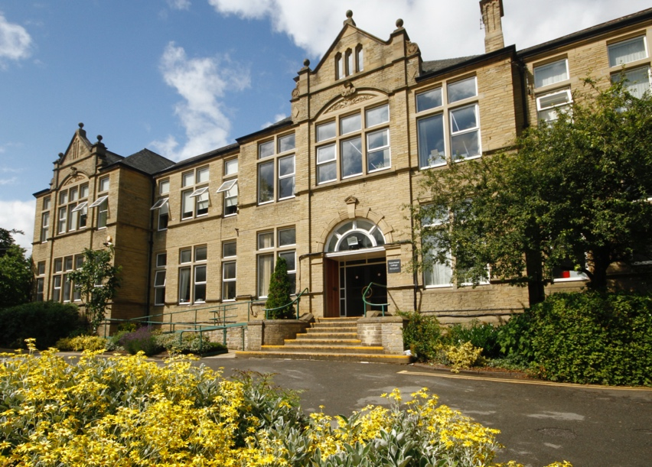


How to Apply: Head of Department - Music

Closing Date:

The closing date for applications is Sunday 21 June 2026 and interviews will take place shortly afterwards.

Applicants for this post are asked to:

- Complete the College’s application form or TES application form and Equality and Diversity form.
- Write a supporting letter of application, with CV if you consider it useful.

Please send the completed documents to:

Jen Rothery, HR Manager, as an email attachment to jobs@greenhead.ac.uk

Safer Recruitment:

Greenhead College is committed to safeguarding the welfare of all of its students and staff. The successful candidate will have to meet the requirements of the person specification in order to be offered the post and will be subject to safer recruitment checks. This position is working in regulated activity and therefore exempt from the Rehabilitation of Offenders Act 1974. Applicants will be required to self-disclose particular criminal convictions should they be shortlisted for interview. Further details can be found within the DBS filtering guide at https://www.gov.uk/government/publications/dbs-filtering-guidance

All offers of employment are subject to the following pre-employment checks:

- Two satisfactory references
- Enhanced DBS check with barred check list
- Overseas check if you have lived or worked abroad within the last five years
- Evidence of the right to work in the UK
- Prohibition check order
- Qualifications
- Fitness for Work

In line with KCSIE 2025 guidance, all shortlisted candidates will be subject to an online search.

If you apply and are unsuccessful in being called to interview, can we thank you in advance for your time and trouble in making this application. Due to time constraints, it would be impossible to respond to everyone individually - we hope that you will understand.

Greenhead College is committed to creating a welcoming, inclusive and supportive environment for all. We value diversity in our community and actively encourage applications from individuals of all backgrounds.

Person Specification – Head of Department - Music
 | Essential | Desirable
QUALIFICATIONS:
Degree or equivalent | ×
Teaching qualification | ×
Evidence of appropriate continuing professional development | ×
Further degree |  | ×

 | Essential | Desirable
EXPERIENCE:
Evidence of teaching experience or successful teacher training | ×
Evidence of substantial and successful A Level teaching with a proven track record of raising student achievement |  | ×
Evidence of knowledge and practice of development in subject area teaching | ×
Ability to work with large groups of students in the classroom, in performance and in Enrichment | ×
Experience of curriculum development | ×
Experience of leading/coordinating an A Level specification |  | ×
Work for Examination Board |  | ×
Strong instrumental and music theory skills | ×
Experience of developing teaching, learning and assessment strategies, including ILT in the curriculum subject area |  | ×
Experience of working with other stakeholders to raise student achievement, e.g. parents, carers, outside agencies, etc |  | ×

 | Essential | Desirable
SKILLS & ABILITIES:
Capacity to motivate, encourage and inspire students of all abilities | ×
Ability to work flexibly and to be self-motivated | ×
A passion for the subject area | ×
Experience of development and using innovative teaching materials | ×
Willing to contribute to subject related enrichment activities | ×

 | Essential | Desirable
ATTRIBUTES
Ability to empathise with 16-19 age range | ×
Courteous, positive, and can-do approach | ×
A commitment to quality | ×
A willingness to be flexible | ×
A commitment to safeguarding and promoting the welfare of young people | ×
A commitment to diversity and inclusion and an understanding of the College’s policies | ×
Positive and professional approach with a high level of commitment to the College | ×

The above criteria will be assessed by the: Letter of Application, Interview & Assessments.

