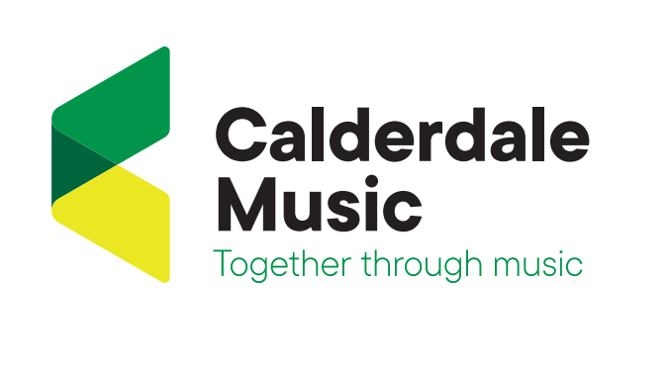
About Us
Making music is inherently human: it connects us, has the ability to improve our lives and brings people together. It also helps people to grow in self- esteem, build essential skills and lead bright futures.
It’s the reason we exist: to help the young people, schools and communities of Calderdale to have access to – and benefit from – life-enhancing music and arts opportunities.
Calderdale Music Trust was established in May 2015 having previously been part of the local authority when it was known as Calderdale Music Service.
In 2019, we took an important step forward in our transformational journey. We made changes to our structure and the way we operate, including the appointment of a new leadership team who share a passion and vision for making a positive difference in the communities we serve.
Marking a new chapter, we have invested in our stunning new flagship HQ in Halifax, that will make it easier to bring people together, providing a community base for live performances, private lessons, a place to gather, and much more.
We also listened to feedback from our schools, parents and our team resulting in our new name and brand identity: Calderdale Music.
There’s no final destination; we see this as an ongoing journey to keep doing better and providing better services, which we’ll do by listening to the needs of our learners, their guardians, schools and hub partners.
Our ambition is to create an inclusive, forward- looking service that puts people and their unique musical learning adventures at the heart of everything we do.
We currently work with thousands of children, young people and adults, and this figure continues to rise year on year.
We take pride in our professional development (CPD) offering to schools and our flexible, bespoke approach to teaching, working around the curriculum to make music a fun and pleasurable experience for young people. Our music leaders are among the best in the sector. We offer much more than just music education, we provide support, performance opportunities and a community for learners from all backgrounds to come together socially and share a passion – or just try out something different.
Although steeped in musical history, and without doubt some of the finest brass bands in the world, we believe Calderdale can do more to reflect and celebrate its musical and cultural diversity.
So as the lead organisation for Calderdale Music Hub, we’re working with local schools, cultural organisations and community groups to bring exciting opportunities and live performances to the doorsteps of Calderdale. We’re here to shine a spotlight on the amazing talent, diversity and prospects our region has to offer.
Our vision for the future is to open life-long music and arts education opportunities to all, providing a cultural heart for Calderdale that unites, motivates and inspires people to live more creative lives.

Calderdale Music provides and supports
Whole Class Ensemble and School Curriculum Teaching
Calderdale Singing Initiatives
Instrumental tuition including strings, piano, woodwind, guitar, brass, keyboard, singing and percussion.
Ensembles
Workshops

Living & working in West Yorkshire
West Yorkshire is a metropolitan county of Northern England, and consists of five metropolitan boroughs: Calderdale, Kirklees, and the city of Bradford in the west and the cities of Leeds and Wakefield in the east. It has a population of approximately 2.2 million and is surrounded by breath taking valleys and the moors of the Pennines. The Peak District National Park is only a short drive away and the Yorkshire Dales National Park, Nidderdale and the Forest of Bowland Areas of Outstanding Beauty are less than 90 minutes away.
There is a lot to explore in West Yorkshire from music festivals to museums, art galleries, contemporary dining to quirky cafes, an outdoor swimming pool nestled in the middle of the Yorkshire countryside with the moors as its backdrop and a number of iconic towns to enjoy and discover.
Our history of strong educational attainment, safe communities, rich heritage and culture offer a variety of pastoral pursuits that makes Yorkshire a residence of choice.
Travelling further afield we have convenient connectivity to the M62 and M1, as well as the internal urban motorways in Leeds and Bradford. We also border the counties of Derbyshire, Greater Manchester, Lancashire, North Yorkshire, and South Yorkshire.

