JOB APPLICATION FORM
Nottingham Music Service
2026
JOB APPLICATION FORM
Trainee Instrumental Teacher
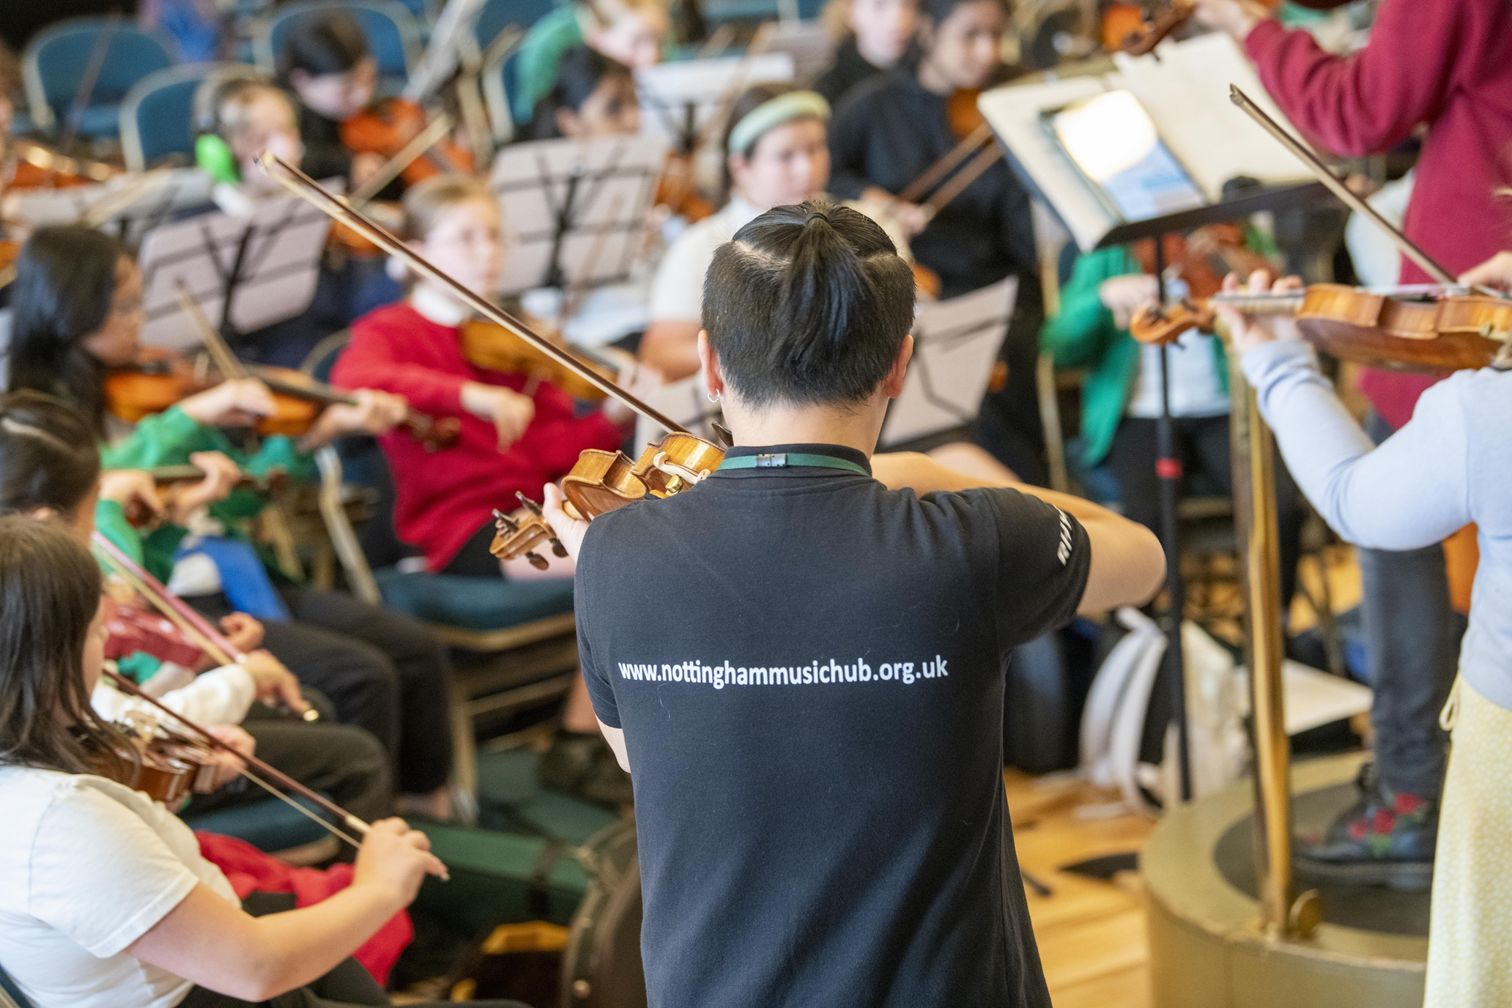

Recruitment Information

Post: Trainee Instrumental Teacher

Base: Nottingham City Schools
Salary: £24,784.50 P/A + Travel Costs

Hours: Full time (37.5 hours per week)

Contract: 12-month fixed term

Start Date: September 2026
Holidays: School Holiday
(No annual leave permitted during term time)

Contents
- Advert
- About Nottingham Music Service
- About the job
- Person specification and job description
- What we are offering
- How to apply
- Application form

If you have any questions regarding this position that you would like to discuss prior to applying, please feel free to contact:
Michael Aspinall – Deputy CEO
Michael.aspinall@nottinghammusichub.org.uk

Job Advert
Trainee Instrumental Teacher

Nottingham Music Service is seeking to appoint a Trainee Instrumental Teacher.
Post: Trainee Instrumental Teacher
Base: Nottingham City Schools
Salary:
Hours: Full time (37.5 hours per week)
Contract: 12-month fixed term
Start Date: September 2026
Holidays: School Holidays
(No annual leave permitted during teaching term time)

This is a fantastic opportunity for enthusiastic and committed instrumentalists with relevant ability and aspirations to support our creative and ambitious organisation.

The successful applicant will support whole class music teaching in city schools, inspire and enthuse children in city ensembles and play a key role in promoting the service aim of providing exciting musical experiences for all children.

This post is a key addition to our team and pivotal in developing a skilled workforce to deliver Whole Class Ensemble teaching, working with children and young people from across Nottingham City. This is an excellent opportunity to gain a solid grounding in instrumental teaching with practical training, learning on the job and the opportunity to gain a recognised Level 4 qualification (Certificate for Music Educators).

The Certificate for Music Educators is a key element of the trainee programme and progress will be reviewed throughout the year. Successful candidates will need to demonstrate appropriate progress by January 2027 to ensure continuation.

The closing date for applications is Tuesday, 5 ^{th}May 2026 (noon).
Shortlisted candidates will be invited to an interview and will be required to deliver an observed practical teaching session in a classroom setting to pupils.
Please note that the applicants must be available to start immediately (September 2026).

Person Specification and Job Description
Organisation: Nottingham Music Service
Job title: Responsible to: Responsible to: Line Manager
Person Specification:
Music and Education
- Strong music skills on instrument, and the ability to support learning on a range of instruments including voice
- Interest in and enthusiasm for inclusive whole class instrumental teaching
- ICT skills (especially within music)
- Capacity to communicate with and enthuse children across the ability range
Mutual respect and good relations
- Ability to build good relationships, working in partnership with school and other city music staff, with respect for different skills and approaches
Inclusion
- Commitment to music for all
- A willingness to recognise and celebrate children’s musical achievements and interests
- Capacity to communicate with and enthuse children across the ability range
- Awareness of the challenges in effective music education for all pupils in a city context
Continuing Professional Development
- Commitment to Continuing Professional Development (CPD) and a willingness to learn
- Ability to be reflective and self-aware to evaluate own teaching and CPD needs
- Commitment to working towards the Certificate for Music Education and gaining the certificate within one year
Safeguarding
Nottingham Music Service is committed to safeguarding and promoting the welfare of children and young people and expects all staff, volunteers and partners to share this commitment.
- An absolute commitment to safeguarding and to ensuring that children and young people are kept safe at all times
Work Related Circumstances
- Ability to travel across the city
- Flexible approach to working hours to enable support for events and activities

Notes:
This post is subject to:
- An enhanced DBS check with children’s barred list check
- Satisfactory references
- Verification of identity and qualifications
- Online/social media checks in line with Keeping Children Safe in Education (KCSIE) guidance
- This role is funded through Arts Council England Music Hub funding and is subject to continuation of external funding.
- Due to the nature of these posts, a flexible approach to hours will be necessary and may include regular evening and weekend work to support performances and other initiatives. With proportional posts, hours and days may vary according to changing school/government demand
- This is not a complete statement of all duties and responsibilities of these posts. The post holders may be required to carry out any other duties as directed by a supervising manager, the responsibility level of any other duties should not exceed those outlined above.
Job Description:
- To work mainly as part of a team (with some individual work where appropriate) supporting the delivery of Whole Class Ensemble and other music programmes within Nottingham City,

- To support city music staff, class teachers, teaching assistants and others, and input into the planning of lessons, suitable for specific school circumstances, tying in to existing schemes of work and assessment procedures, and locating or adapting suitable resources

- Staff are expected to work in line with professional standards for educators and safeguarding guidance including Keeping Children Safe in Education.

- To be part of a team supporting colleagues with area bands, events and other ensembles.

- To attend staff development and training days, develop own skills in line with nationally recognised best practice and work towards gaining the Certificate for Music Educators.

- To take personal responsibility for looking after music service instruments in use during taught sessions and to observe and support staff in ensuring that children are taught safe handling, providing simple servicing, and coordinating with other members of the music service team where more extensive work is necessary

- To contribute to the Music Services aim of providing exciting musical experiences for all children, that connect with the many not the few, and help to raise student and teacher motivation, achievement and self-esteem.

We offer a competitive package which includes:
- A 6% employer contributions into a company pension scheme
- Travel costs in between schools
- A commitment to your continuing professional development
- Work while you train – your CME qualtification and teaching fees paid by NMS and half a day of study time, per week, provided

How to apply
Please send a covering letter and completed application form (copy at the end of this information pack) by email to lucy.gregory@nottinghammusichub.org.uk Please note applications can only be received by e-mail.

The closing date for applications is Tuesday, 5th May 2026 (noon).
Please note that the applicants must be available to start in September 2026.

Equality, Diversity and Inclusion Statement
We are committed to fostering an inclusive and diverse workforce and welcome applications from all suitably qualified individuals regardless of age, disability, gender reassignment, marriage and civil partnership, pregnancy and maternity, race, religion or belief, sex, or sexual orientation.
We are committed to making reasonable adjustments throughout the recruitment process and employment.

Application Form
By submitting this application, you consent to Nottingham Music Service processing your personal data for recruitment purposes in accordance with the UK General Data Protection Regulation (UK GDPR) and the Data Protection Act 2018.
Your data will be stored securely and retained only for as long as necessary for recruitment purposes. You have the right to access, rectify, or request deletion of your data at any time.
Position: Instrumental Teacher
Please list you main and secondary instruments:

How did you hear about this job?

1. Personal details
Please only provide information for where we are free to contact you.
Name
Address
Post code

Telephones
Email
Do you hold a full driving licence? |  | Yes / No
Do you have daily use of a vehicle? |  | Yes / No

2. References
Please list two people whom we may approach for professional references. One of these should be your current or most recent employer
Name:
Position:
Organisation:
Address:
Telephone:
Email:
May we contact this referee before interview? |  | Yes / No

Name:
Position:
Organisation:
Address:
Telephone:
Email:
May we contact this referee before interview? |  | Yes / No

Nottingham Music Service reserves the right to take up references, after a conditional offer has been accepted, with any or all of your previous employers.

3. Experience
Present/Most recent employment
Job title
Employer
Address

Contact person
Telephone
Date appointed
Reason for seeking other employment
Duties and achievements
Present salary or fee income
Notice required – if applicable

Have you ever been subject to Disciplinary Proceedings? Yes / No
If yes, please indicate the outcome

4. Previous employment – If necessary, please provide details of additional employers on a separate sheet

Employer name and address

Dates

Duties and achievements

Employer name and address

Dates

Duties and achievements

Employer name and address

Dates

Duties and achievements

5. Health Declaration (Post-Offer Only)
Health-related questions will only be asked following a conditional offer of employment and will be used solely to determine fitness for the role and any reasonable adjustments required.

6. Qualifications and training
Education | Please list your relevant educational details
Qualifications | Please list your relevant qulification details
Training | Please list your relevant training details

7. Supporting information
Please tell us, referring to each point of the person specification and job description, why you believe you are a suitable candidate for this position. Use extra sheets if necessary.

A Right to Work in the UK  All applicants must demonstrate their legal right to work in the UK in accordance with Home Office requirements.  Documentation will be checked prior to appointment. | YES / NO

This post is subject to:
- An enhanced DBS check with children’s barred list check
Criminal Convictions Disclosure
Due to the nature of this role, applicants are required to disclose any criminal convictions, cautions, or reprimands that are not protected (i.e. not filtered) under DBS legislation.
This information will only be considered in relation to the role and in line with safeguarding requirements.
- Satisfactory references
- Verification of identity and qualifications
- Online/social media checks in line with Keeping Children Safe in Education (KCSIE) guidance
We follow safer recruitment practices in line with statutory guidance.

8. Declaration
Signature |  | Date
When completed please return this form to: | lucy.gregory@nottinghammusichub.org.uk

Please note that to knowingly provide false or deliberately misleading information may lead to disciplinary action being taken, up to and including dismissal, at any time after an appointment is made.

